My Work Habits – Junior
– Group Assignment

Find someone who…

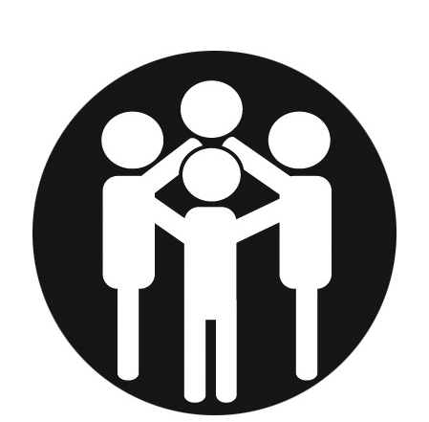
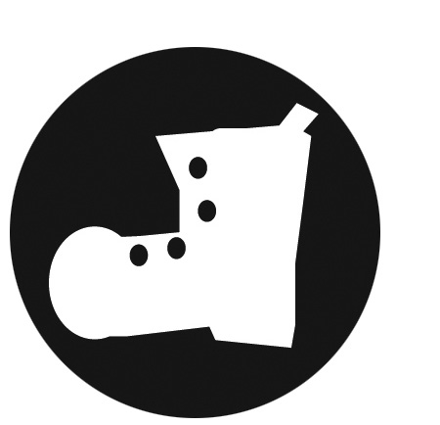
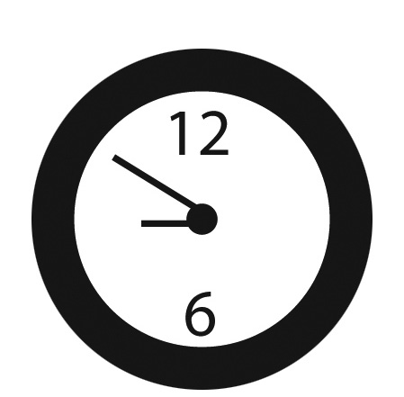

Wears a helmet when they bike, rollerblade or snowboard.
Completes their fair share of
group assignments.
Returns items they borrow on time (e.g., library books).

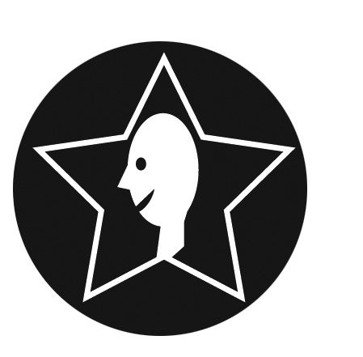
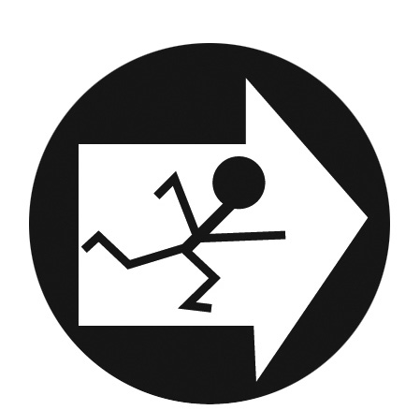

Uses their planner to know
when assignments are due.
Can be depended on to complete homework and assignments.
Volunteers in the school and participates in extracurricular activities.

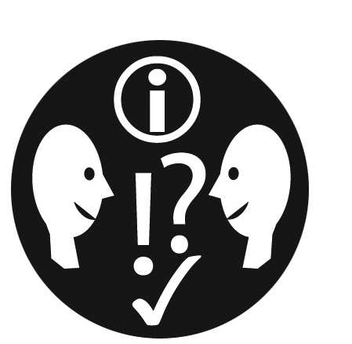
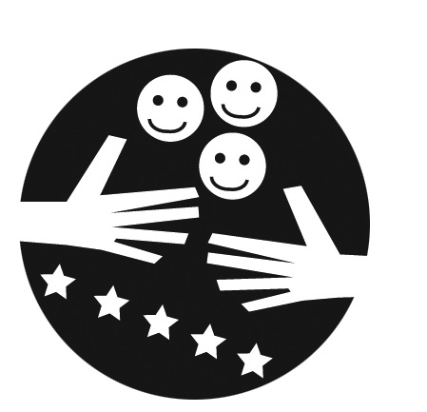

Can stand up to bullies. Is friendly with people, even if they’re having a bad day.
Thinks of ideas for fundraisers for
school trips or social justice events.

